Assignment SQL Notebook for Peer Assignment
Estimated time needed: 60 minutes.
Introduction
Using this Python notebook you will:
- Understand the Spacex DataSet
- Load the dataset into the corresponding table in a Db2 database
- Execute SQL queries to answer assignment questions
Overview of the DataSet
SpaceX has gained worldwide attention for a series of historic milestones.
It is the only private company ever to return a spacecraft from low-earth orbit, which it first accomplished in December 2010. SpaceX advertises Falcon 9 rocket launches on its website with a cost of 62 million dollars wheras other providers cost upward of 165 million dollars each, much of the savings is because Space X can reuse the first stage.
Therefore if we can determine if the first stage will land, we can determine the cost of a launch.
This information can be used if an alternate company wants to bid against SpaceX for a rocket launch.
This dataset includes a record for each payload carried during a SpaceX mission into outer space.
Download the datasets
This assignment requires you to load the spacex dataset.
In many cases the dataset to be analyzed is available as a .CSV (comma separated values) file, perhaps on the internet. Click on the link below to download and save the dataset (.CSV file):
Spacex DataSet
!pip install sqlalchemy==1.3.9
Connect to the database
Let us first load the SQL extension and establish a connection with the database
!pip install ipython-sql
!pip install ipython-sql prettytable
Then
%load_ext sql
Then
import csv, sqlite3
import prettytable
prettytable.DEFAULT = 'DEFAULT'

con = sqlite3.connect("my_data1.db")
cur = con.cursor()
Then
!pip install -q pandas
Then
%sql sqlite:///my_data1.db
Then
import pandas as pd
df = pd.read_csv("https://cf-courses-data.s3.us.cloud-object-storage.appdomain.cloud/IBM-DS0321EN-SkillsNetwork/labs/module_2/data/Spacex.csv")
df.to_sql("SPACEXTBL", con, if_exists='replace', index=False,method="multi")
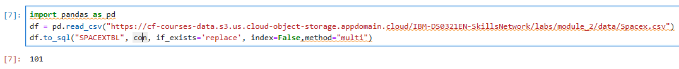
Note: This below code is added to remove blank rows from table
#DROP THE TABLE IF EXISTS

%sql DROP TABLE IF EXISTS SPACEXTABLE;
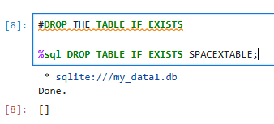
%sql create table SPACEXTABLE as select * from SPACEXTBL where Date is not null
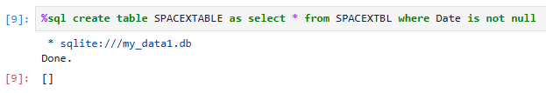
Tasks
Now write and execute SQL queries to solve the assignment tasks.
Note: If the column names are in mixed case enclose it in double quotes For Example "Landing_Outcome"
Task 1
Display the names of the unique launch sites in the space mission
%%sql
SELECT DISTINCT Launch_Site FROM SPACEXTABLE;
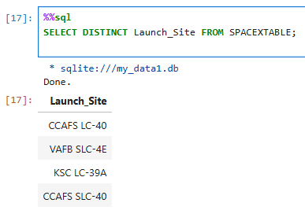
Task 2
Display 5 records where launch sites begin with the string 'CCA'
%%sql
SELECT *
FROM SPACEXTABLE
WHERE Launch_Site LIKE 'CCA%'
LIMIT 5;
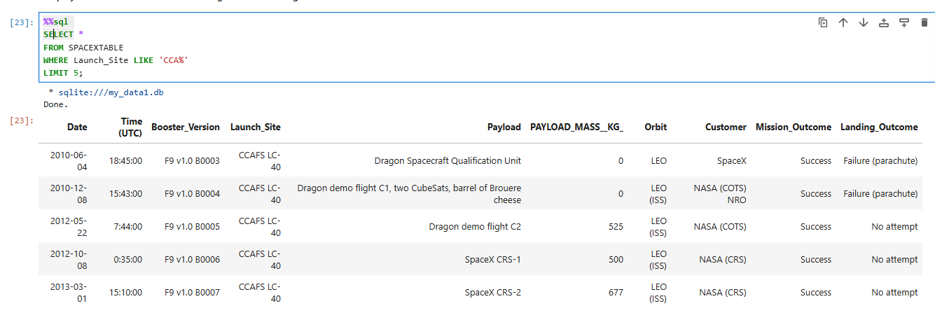
Task 3
Display the total payload mass carried by boosters launched by NASA (CRS)
(I had to confirm the spelling for the column first – separately)
%%sql
PRAGMA table_info(SPACEXTABLE);
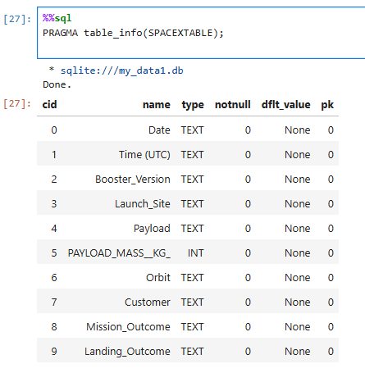
Then
%%sql
SELECT SUM(PAYLOAD_MASS__KG_)
FROM SPACEXTABLE
WHERE Customer LIKE 'NASA (CRS)';
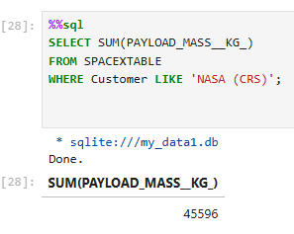
Task 4
Display average payload mass carried by booster version F9 v1.1
%%sql
SELECT AVG(PAYLOAD_MASS__KG_)
FROM SPACEXTABLE
WHERE Booster_Version LIKE 'F9 v1.1%';
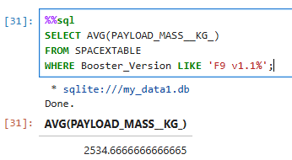
Task 5
List the date when the first successful landing outcome in ground pad was achieved.
Hint:Use min function
%%sql
SELECT MIN(DATE)
FROM SPACEXTABLE
WHERE Landing_Outcome LIKE 'Success (ground pad)';
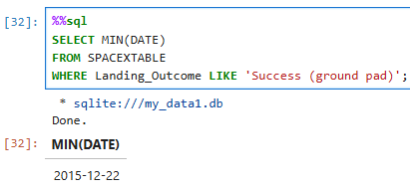
Task 6
List the names of the boosters which have success in drone ship and have payload mass greater than 4000 but less than 6000
%%sql
SELECT Booster_Version
FROM SPACEXTABLE
WHERE Landing_Outcome LIKE 'Success (drone ship)'
AND PAYLOAD_MASS__KG_ >=4000
AND PAYLOAD_MASS__KG_ <6000;
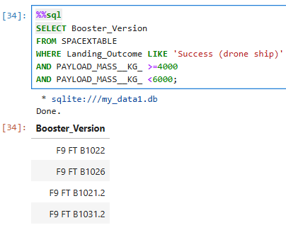
Task 7
List the total number of successful and failure mission outcomes
%%sql
SELECT COUNT(*)
FROM SPACEXTABLE
WHERE Landing_Outcome LIKE 'Success%'
OR Landing_Outcome LIKE 'Failure%';
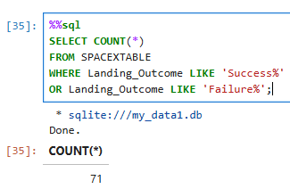
Task 8
List all the booster_versions that have carried the maximum payload mass, using a subquery with a suitable aggregate function.
%%sql
SELECT Booster_Version, PAYLOAD_MASS__KG_
FROM SPACEXTABLE
WHERE PAYLOAD_MASS__KG_ =(
SELECT MAX(PAYLOAD_MASS__KG_)
FROM SPACEXTABLE
);
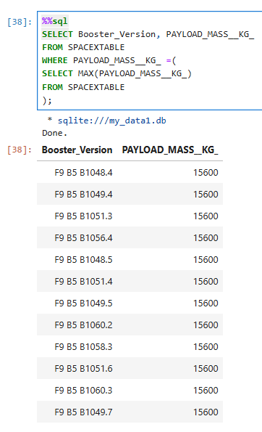
Task 9
List the records which will display the month names, failure landing_outcomes in drone ship ,booster versions, launch_site for the months in year 2015.
Note: SQLLite does not support monthnames. So you need to use substr(Date, 6,2) as month to get the months and substr(Date,0,5)='2015' for year.
%%sql
SELECT substr(Date, 6, 2) AS Month, Landing_Outcome, Booster_Version, Launch_Site
FROM SPACEXTABLE
WHERE substr(Date, 1, 4) = '2015'
AND Landing_Outcome LIKE 'Failure (drone ship)';
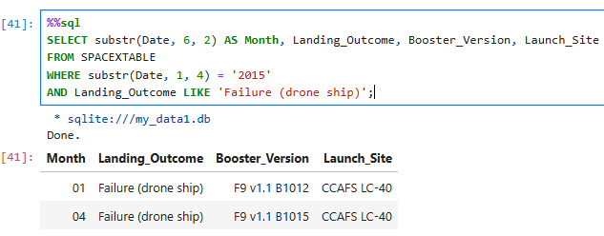
Task 10
Rank the count of landing outcomes (such as Failure (drone ship) or Success (ground pad)) between the date 2010-06-04 and 2017-03-20, in descending order.
%%sql
SELECT Landing_Outcome,
COUNT(*) AS Outcome_Count,
RANK() OVER (ORDER BY COUNT(*) DESC) AS Rank
FROM SPACEXTABLE
WHERE Date BETWEEN '2010-06-04' AND '2017-03-20'
GROUP BY Landing_Outcome;
